**Information system** is organized combination of people (users, specialists), data, information, hardware (machine and media) , software (programs and procedures) , communication, resources and techniques to perform input, processing, output, storage, and control activities that transform data resource into information products.

**Needs of Information**

* + Decision Making
  + Planning and Forecasting
  + Operational Efficiency
  + Performance Monitoring
  + Risk Management
  + Understanding customer needs
  + Innovation
  + Employee Engagement and Development
  + Stakeholder Communication

**Characteristics of Information**

* + Quality
  + Timeliness
  + Completeness
  + Relevance
  + Accurate
  + Flexible
  + Simple
  + Secured
  + Verifiable

**Information system** is organized combination of people (users, specialists), data, information, hardware (machine and media) , software (programs and procedures) , communication, resources and techniques to perform input, processing, output, storage, and control activities that transform data resource into information products.

**Building Blocks of Information System/Components of Information System**

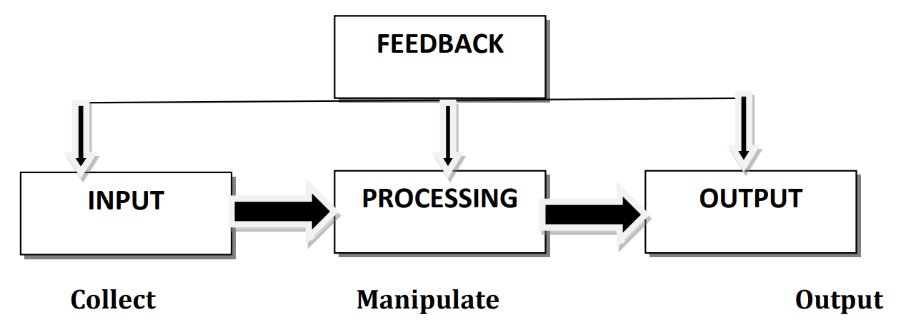

**CBIS (Computer Base Information System)**

* + Hardware
  + Software
  + Database
  + Telecommunication, Network, Internet
  + People (User)
  + Procedure (Includes set of Rules and Regulations)

**UNIT – 2**

A **system in an organization** is a network of interconnected elements, such as people, processes, technologies, and resources, that function together to accomplish specific objectives or tasks efficiently and effectively. It involves the coordinated interaction and integration of various components to produce desired outcomes and adapt to changes in the internal and external environment.

**Different types System**

* + Simple and Complex
  + Open and Closed System
  + Deterministic and Probabilistic System
  + Stable and Dynamic
  + Permanent and Temporary
  + Adaptive and Non-adaptive
  + Sub-system and super-system

